10. React-JS HOL

Name:- Shubham Sangram Bej

Hands-on 10

Objective
- Understand JSX syntax in React.
- Create React elements using JSX.
- Display objects and lists of objects.
- Render images using JSX attributes.
- Apply conditional CSS styling based on data values.

Software Requirements
- Node.js
- npm
- React
- Visual Studio Code

Project Name
officespacerentalapp

Procedure
- Created a new React application named officespacerentalapp.
- Added an office image inside the Images folder.
- Declared an array of office objects containing:
  - Name
  - Rent
  - Address
- Used the map() method to iterate through the office list.
- Displayed the office image using the JSX img element.
- Displayed office details using JSX expressions.
- Applied conditional CSS:
  - Rent ≤ 60000 → Red
  - Rent > 60000 → Green
- Executed the application using:
npm start
- Verified the output in the browser.

Output
The application successfully displays office space details with an image. The rent value is displayed in red when it is less than or equal to ₹60000 and in green otherwise.
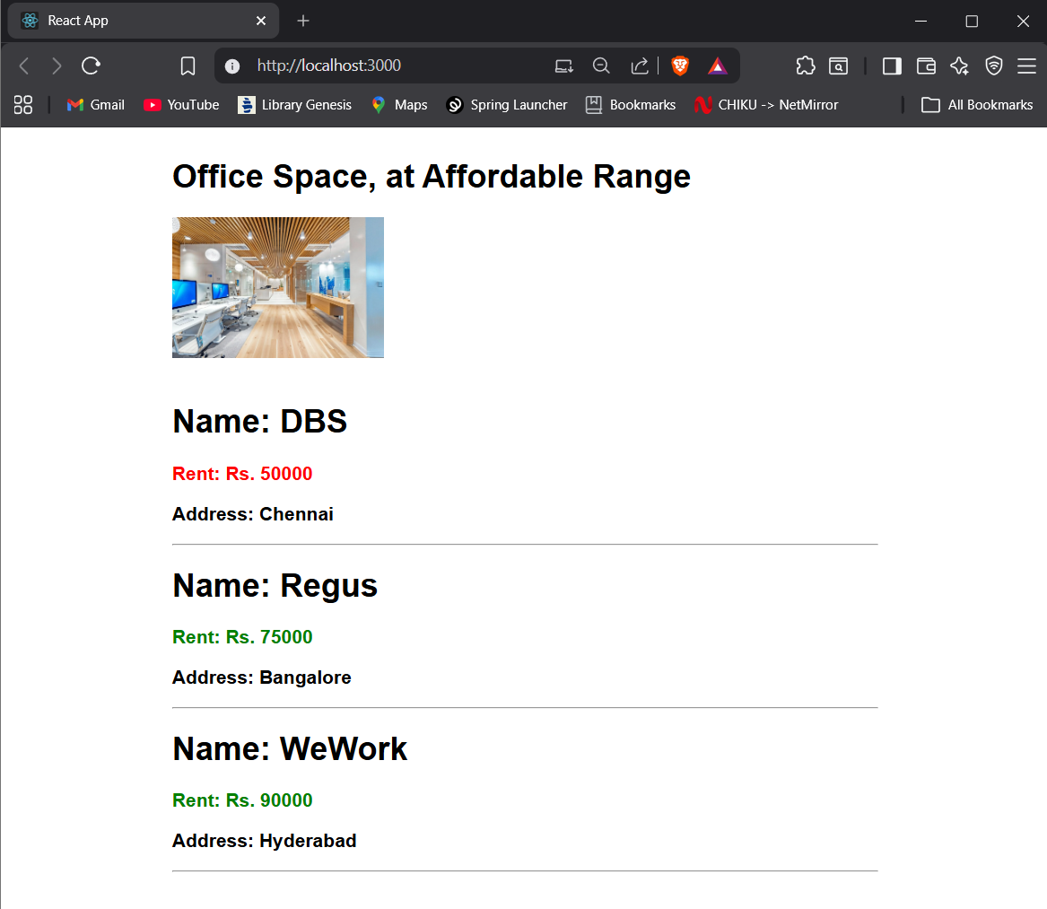

Result
The React application officespacerentalapp was successfully developed using JSX, object rendering, list rendering, and conditional CSS styling.

